**Dokumentasi HCI**

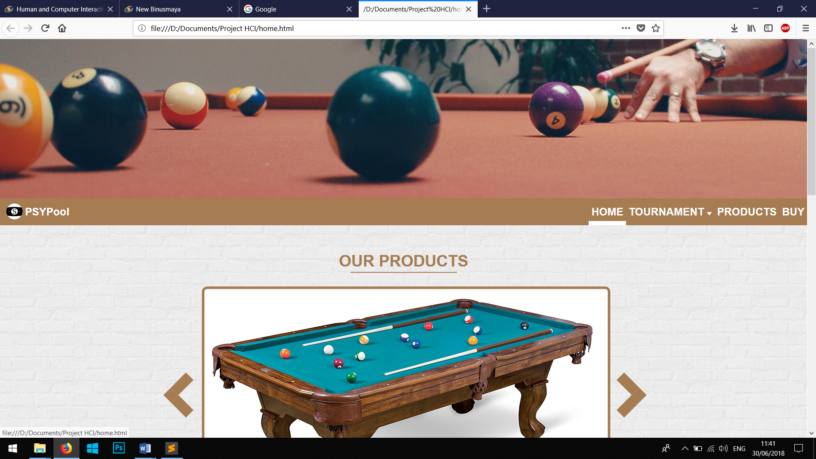

*Tampilan Dekstop*

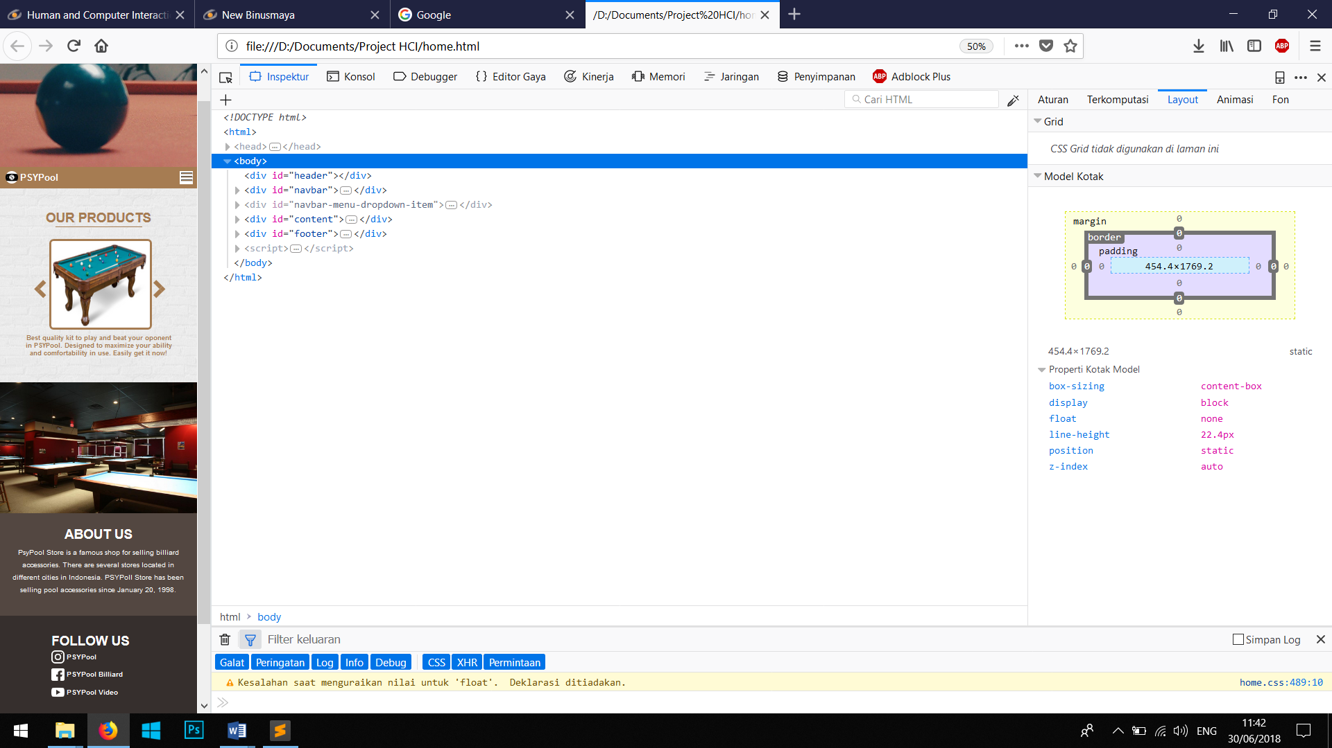

*Tampilan Mobile 500px*

Referensi Gambar:

1. <https://i.ebayimg.com/images/g/6ugAAOSwZWpam272/s-l225.jpg>
2. <https://i5.walmartimages.com/asr/511f6f5a-8032-4aa1-b9d7-d9064dfad39f_1.192e118c9b0ec19bb44c56889d45245e.jpeg?odnHeight=450&odnWidth=450&odnBg=FFFFFF>
3. <https://uae.souq.com/ae-en/metallic-blue-titanium-pool-cue-billiard-stick-35011504/i/>
4. <http://www.clipartpanda.com/categories/billiards-ball-clipart>
5. <https://www.flaticon.es/icono-gratis/marca-del-mapa-simbolo-de-ios-7_15979>
6. <https://www.dhgate.com/product/2017-new-dream-billiard-balls-2-1-4inch-16pcs/405614306.html>
7. <https://www.milanuncios.com/anuncios/aramith.htm>
8. <http://www.easr2018.org/>
9. <https://www.prnewswire.com/news-releases/right-on-cue---galacasinocom-sponsors-world-blackball-pool-star-171009981.html>
10. <https://sguru.org/instagram-logo/>
11. <https://www.postermywall.com/index.php/posters/search?s=pool%20tournament%20poster>
12. <https://www.slideshare.net/usagredcloud/boss-pool-tournament>